­­

NEA SCA Onboarding Tool

Design Writeup

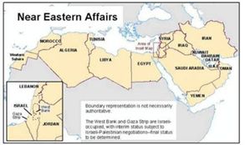**Challenge**: Find a way for new joins to the NEA/SCA division of the U.S. State Department to gain an understanding of the region. Find a way to use this as a policymaking tool.

**Stipulations**: This onboarding method should be both interactive and data-driven; it should embody the State Department as being a data-driven environment. It should work on desktop or mobile, on any size or OS.

Role: Coder, UX/UI Designer, Persona-Builder

Skills: Git, JavaScript, CSS/HTML, Photoshop

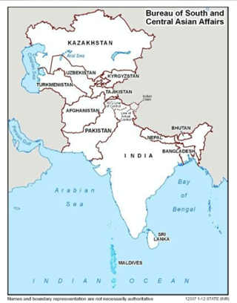Features:

This process/tool could contain:

Comparison metrics (requested)

Timeline

Current news

Interactive maps

Field Research: What already exists if you look up these regions and try to find a brief on them?

Search terms: ‘Near East Asia brief’; ‘South Central Asia brief’

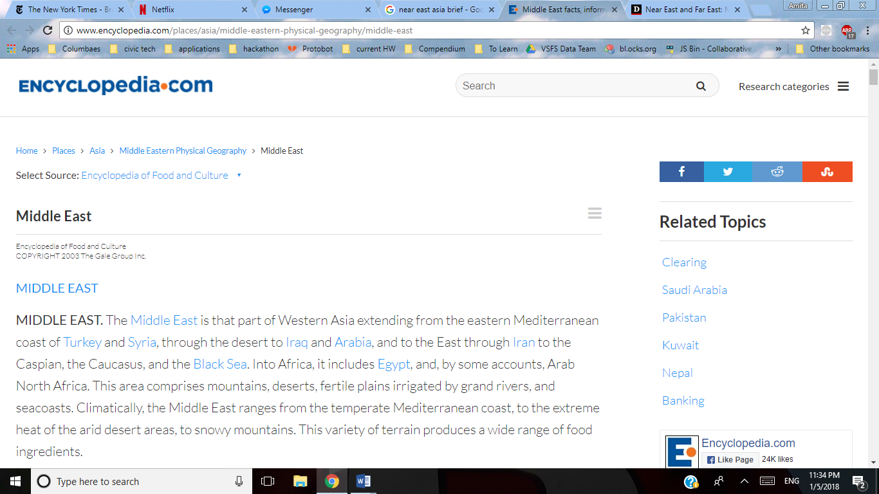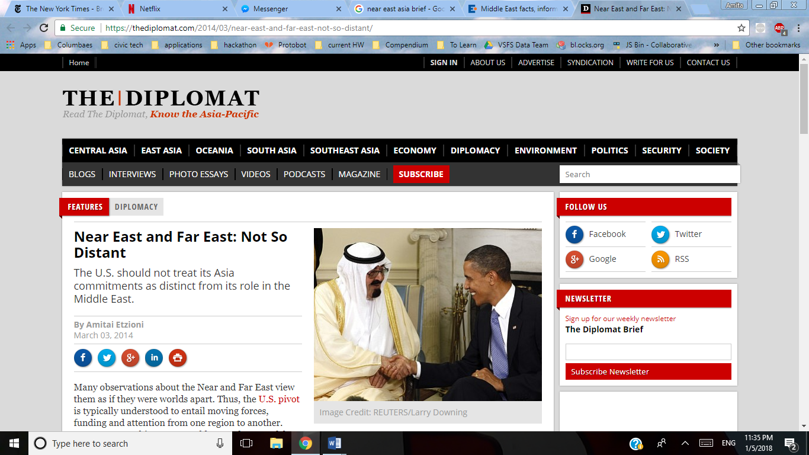

Encyclopedia.com TheDiplomat.com

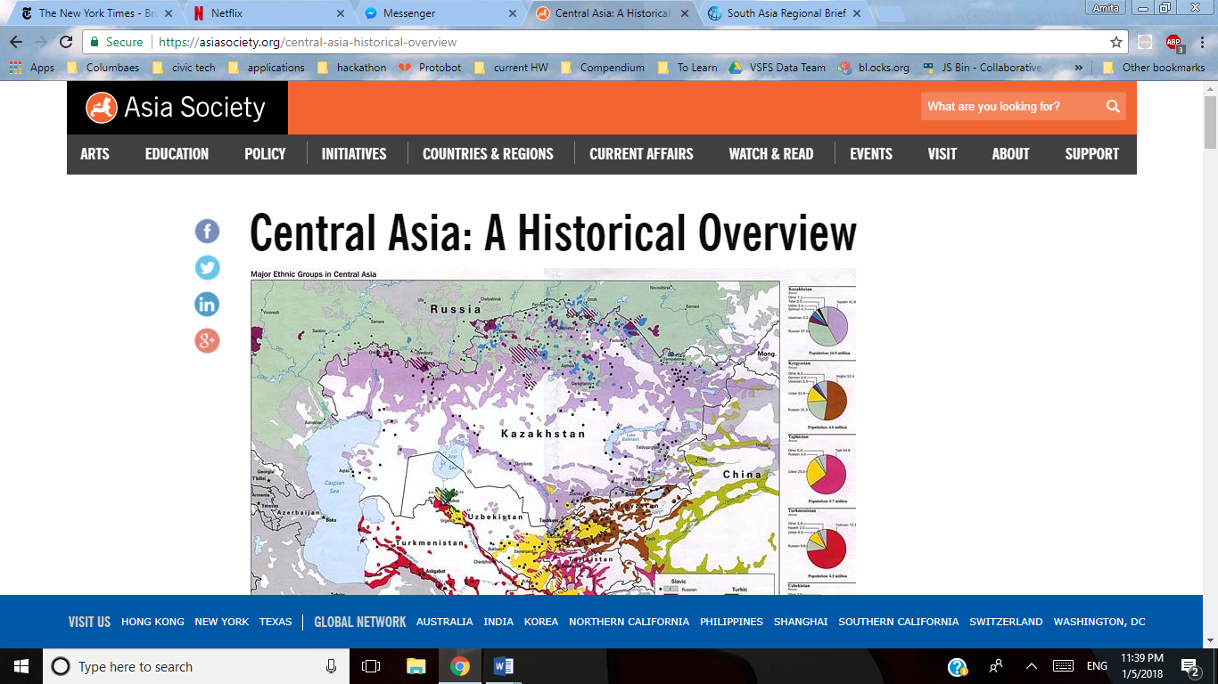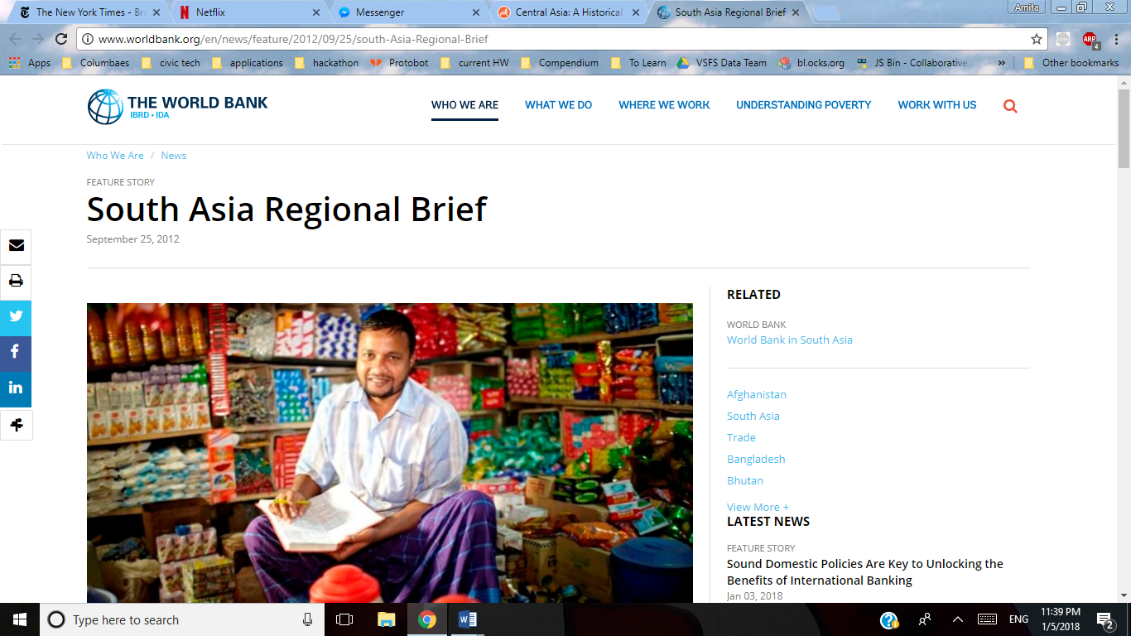

Asia ­Society World Bank

­Critiques:

No interactivity

Difficult to see diplomatic relevance of most information

Cannot compare/contrast

Information is *too* historical

Sources assume significant prior knowledge

Note: Google exists. Realistically, most of the users of this project are going to be utilizing it as a first resource.

So this onboarding tool, if it’s going to be genuinely useful, must offer something that a quick Google search won’t.

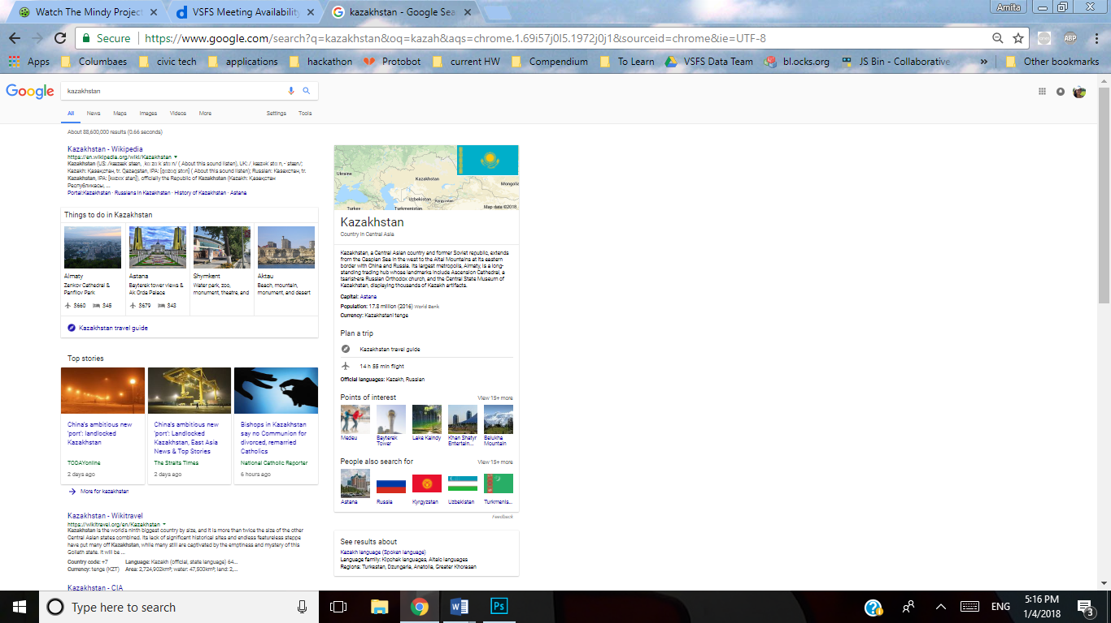

Stage 1: User Visualizations

Usually we’d do actual user interviews, but in this case, that was logistically complex enough that we used personas to design for instead. We’ll return to this once we have our first prototype.

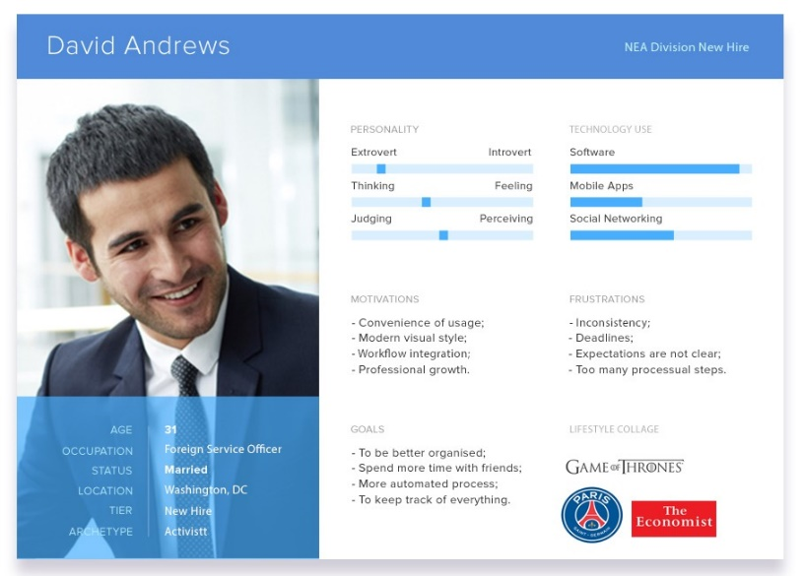

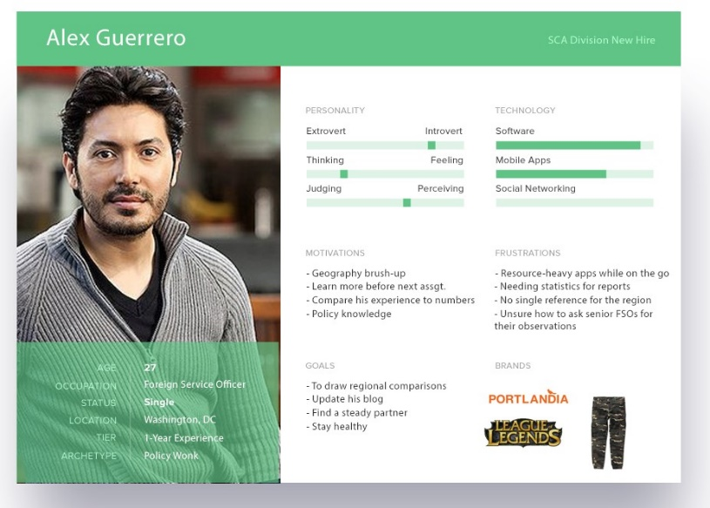

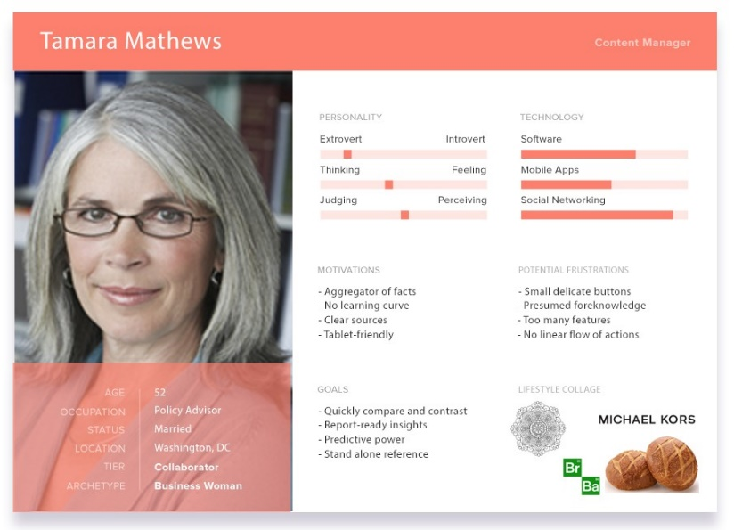

Stage 2: Hand-drawn Sketches

We begin with some rough sketches to figure out what elements might go where.

­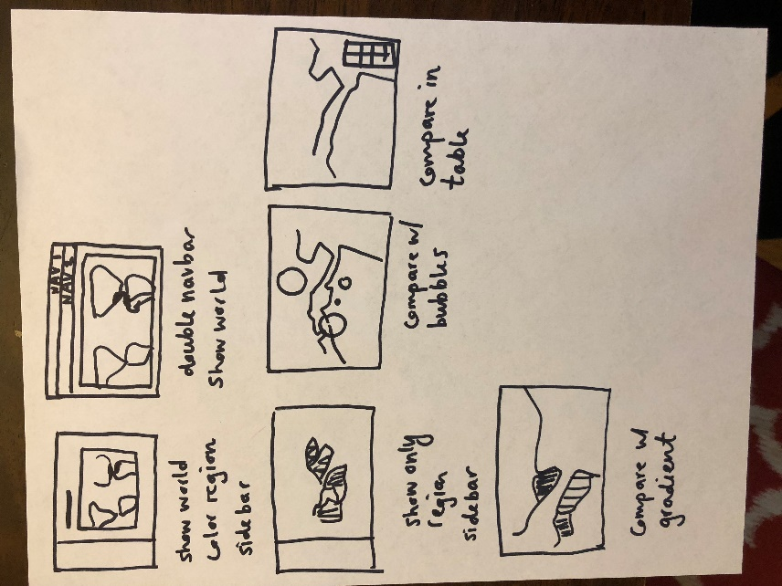 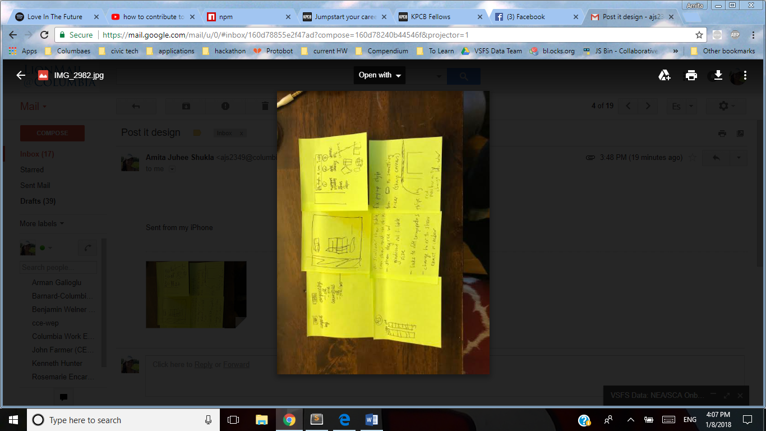

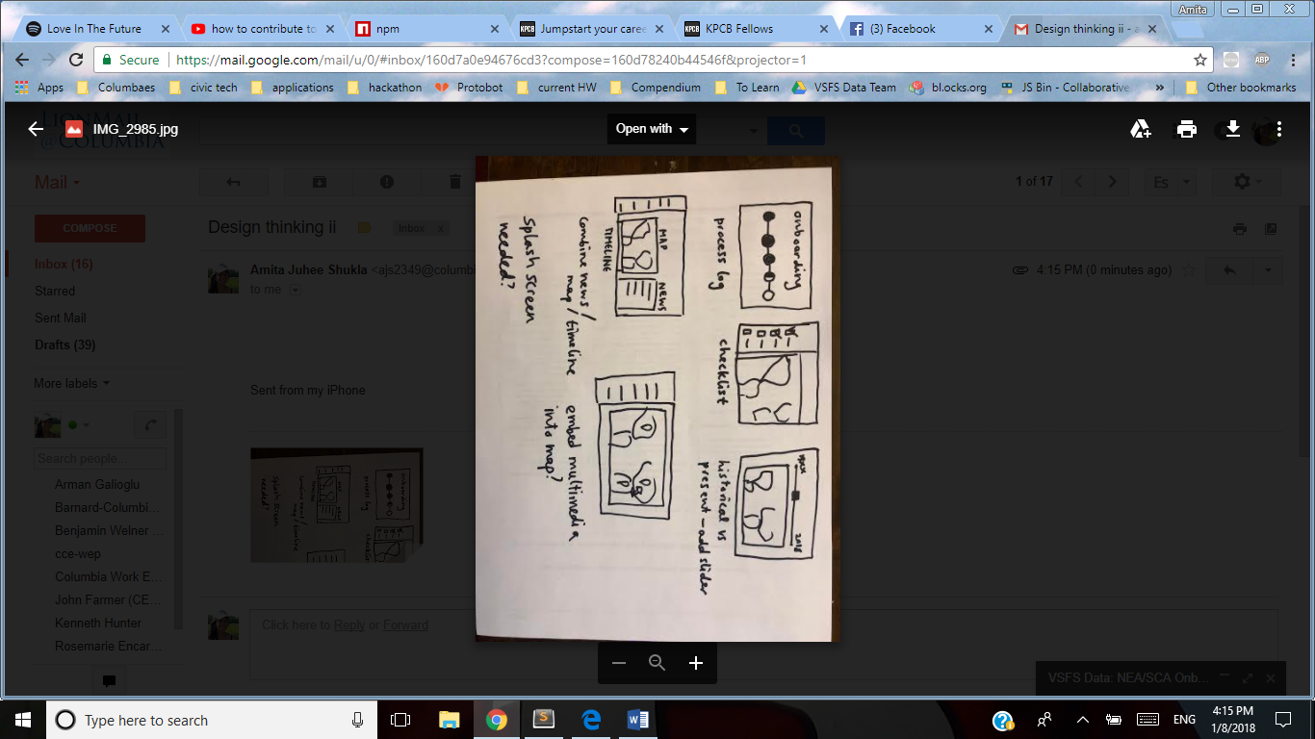

Here, I considered:

-Sidebar vs top navbar(s)

-Y/N splash screen

-Whether there should also be a timeline or news options

-whether the maps should have multimedia embedded in them

-whether the site should be explicitly about onboarding and feature steps to do

Now that we know what we’re keeping in mind, we’ll reason through these questions in the next section.

Stage 3: UX/UI Considerations

More deliberate than the hand-drawn sketches, this stage focuses on specific user interface questions.

What’s the best possible approach?

1. Should we frame this to the user as a ‘process’ with definite, discrete steps, or should it be make-your-own-way?

I decided that the tool should be make-your-own-way to avoid becoming onerous and to make it a handy reference.

1. Should features be in separate tabs or together?

Modular parts show the user what types of information he or she could look for. Separating them prevents overwhelming the user and taking too long to load the page

1. Should it be personalized, save-your-progress or a generalized reference tool?

Having it be make-your-way and as-you-need makes it more useful overall. There’s not really a need for a login.

1. Should there be multimedia?

While multimedia (pictures etc.) might be useful, too much media will detract from the comparisons we are trying to draw.

1. Should there be present news or historical feed?

Realistically, this isn’t going to be a go-to site for news, so that seems like it’s not really adding much. Historical data would be nice, but the CIA World Factbook doesn’t have that, and nowhere else really does either.

1. Should there be a splash screen?

There should be a page explaining how to use the site, but not a full splash screen, to reduce loading time—the maps are already going to make it slower than most sites.

Stage 4: Technical Considerations

The two aspects of the project needing the most attention are the data (source, frequency of updates, etc) and the maps.

Map:

Possible Map Libraries

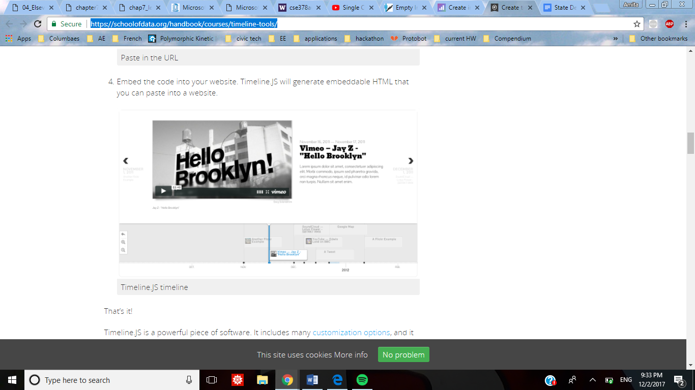 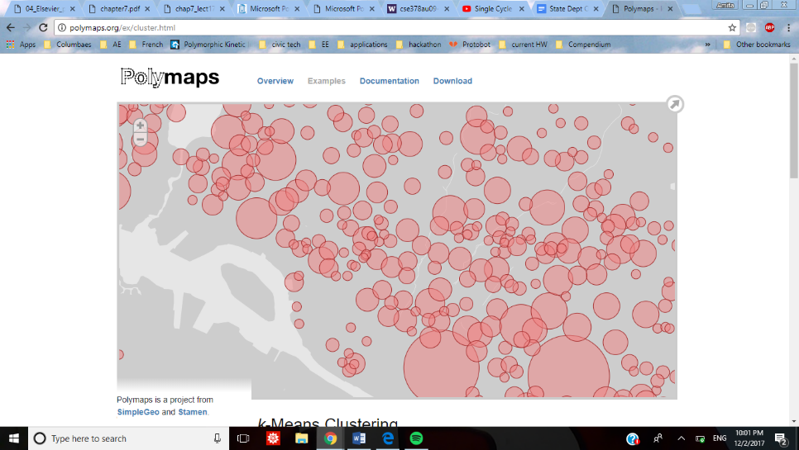

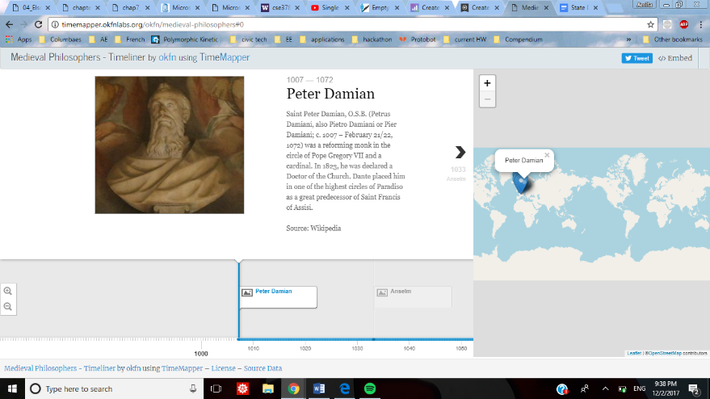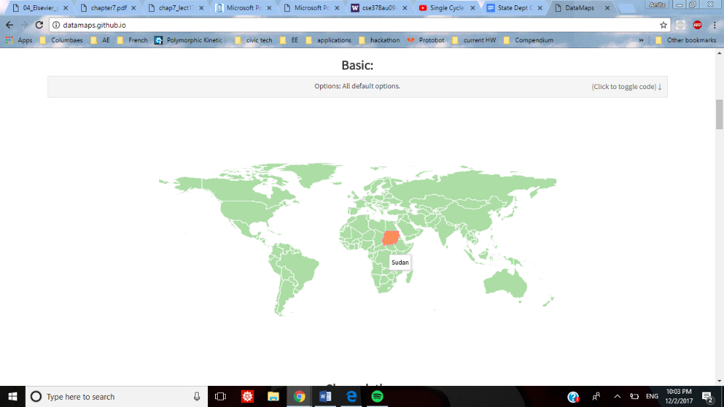

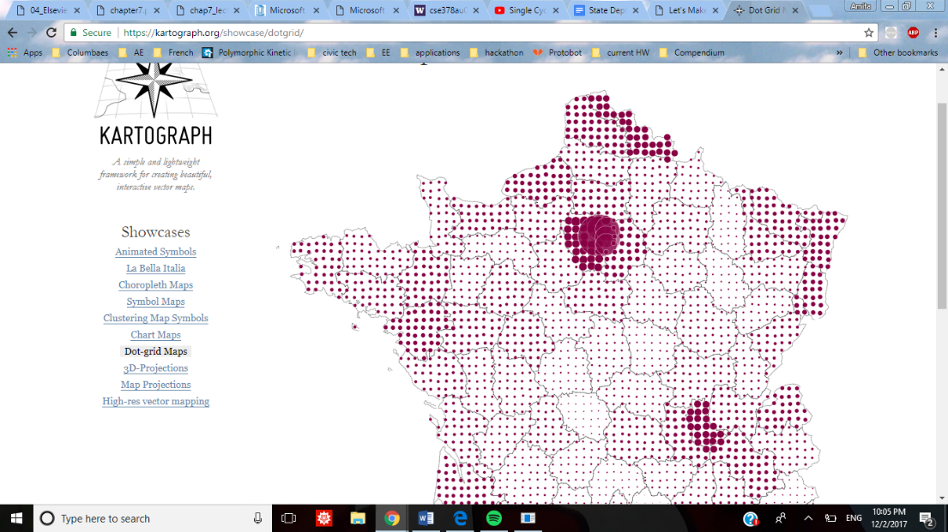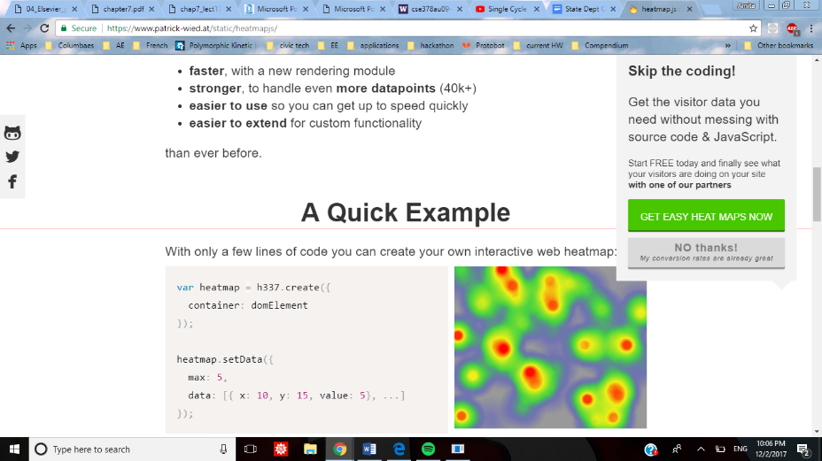

I found so many options here: TimeLine and TimeMapper are fit best to embed interactivity, which I decided earlier wasn’t necessary. Kartograph is for more density of data than I have, and so is HeatMaps. That leaves DataMaps as the best candidate.

Data: I found four candidate sites for drawing data from:

NationMaster

ChathamHouse

World Bank

CIA

While all of them have high-quality data, Chathan House doesn’t have an API, nor does Nation Master, so those are out. World Bank does, but it’s only about economic data, and we want to have some social issues too.

That leaves the CIA World Factbook as my choice.

So DataMaps and the World FactBook are the underlying framework of our site.

I considered also whether the service should be an app, a web app, or a web site.

I thought it would be limiting to make it just an app, as well as add development costs. Between web app and web site, I chose something of a hybrid—while it is interactive, the site doesn’t really need a formal backend because we don’t have logins and all the data is pulled from the CIA. So it’s a web site with some web-app-like components.

Stage 5: First Build

Process:

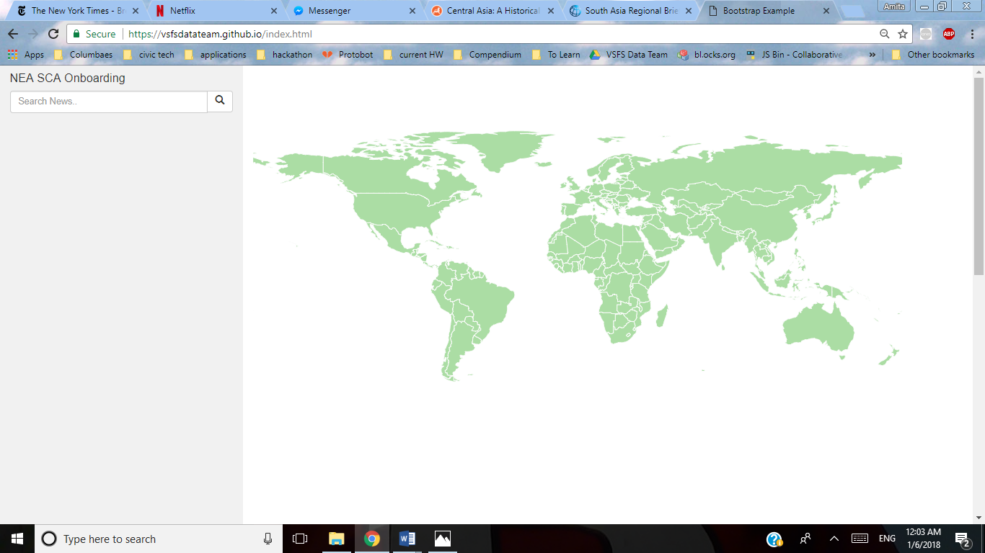

Step 1: Getting the map working

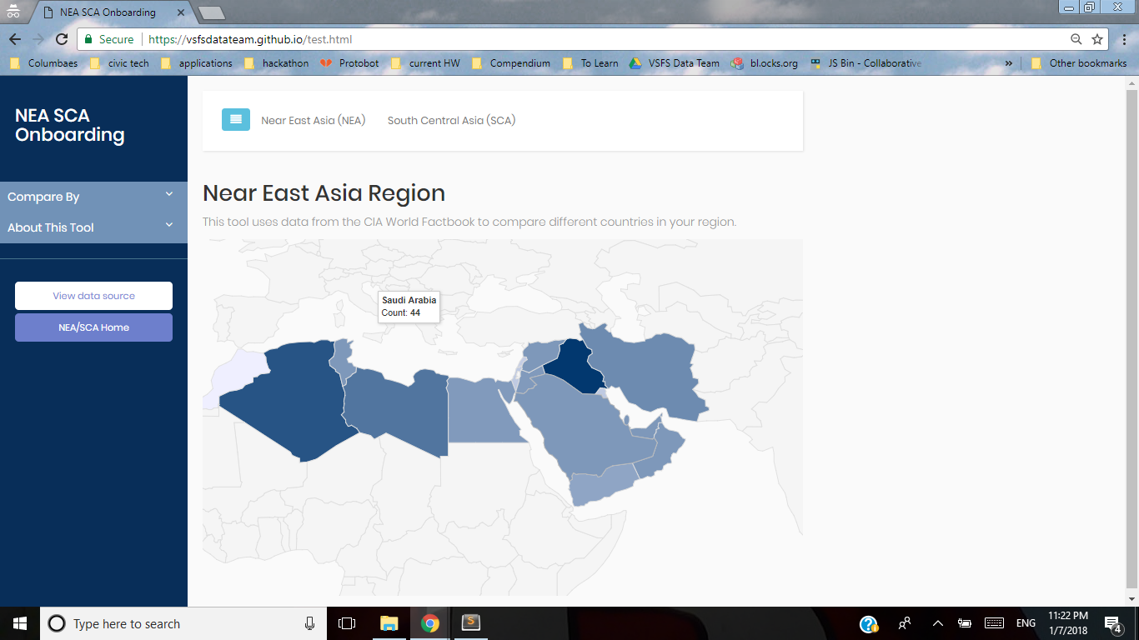

Step 2: Color picking; basic web framework; interactivity

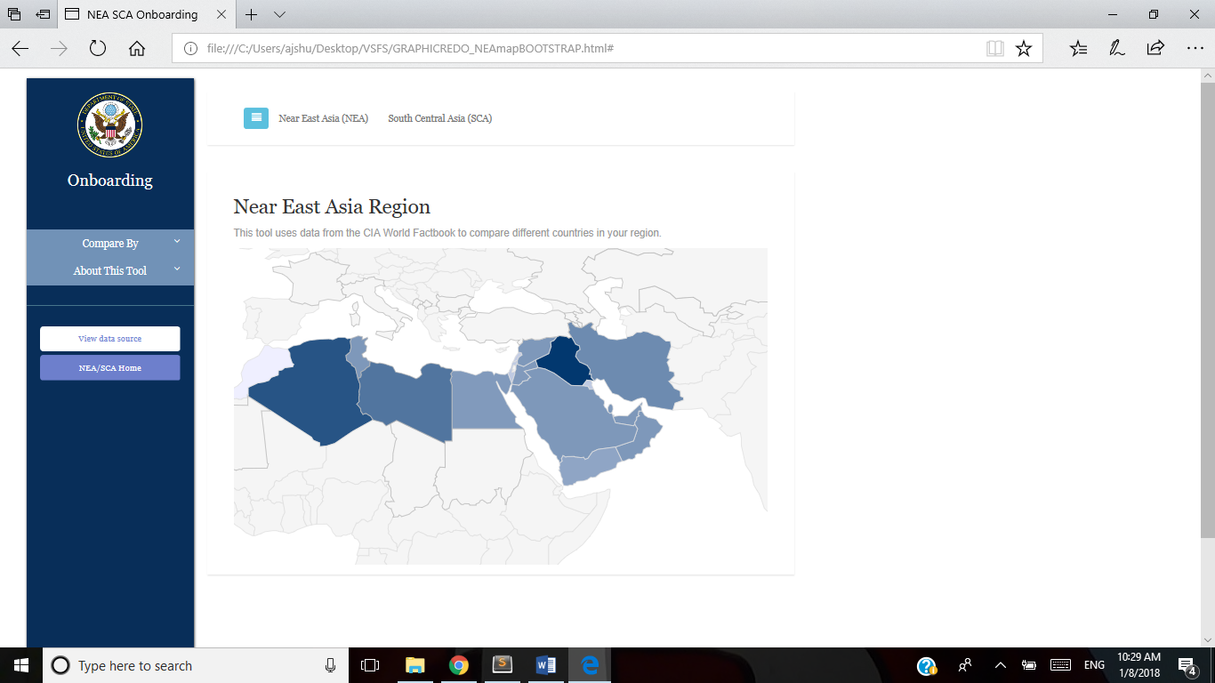

Step 3: Responsiveness, better loading, browser compatibility

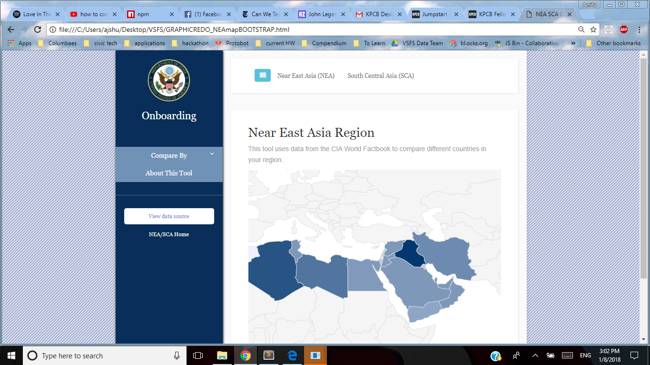

Step 4: Cleaner design

Step 6: Evaluation

Works well Needs fixing

|  |  |
| --- | --- |
| -Gradient in combination with numbers: both visual and numerical  -Clean color scheme  -Cross-browser compatible | -Should maps be sorted by region?  -We probably want a table view—what should that look like?  -Should we be able to see each country individually?  -Should you be able to compare two specific countries on every datatype? |
|  |  |
|  |  |
|  |  |
|  |  |

Future additions:

This project could also:

Introduce insights from senior FSOs in the region.

Show comparisons between NEA/SCA regions with world at large

Include also UN and/or US aid to the region (<https://www.foreignassistance.gov/developers>)

Step 7: Interview some real users

Throughout this process, I got feedback from many stand-in users who commented on the usability and design of the site.

To maximize the utility of this tool, it should be tested with its intended users!

To be continued…

What does the current onboarding process look like?

What devices are they likely going to be using?